How To Submit a Question to Our Office
Can't find what you are looking for in our knowledge articles? Feel free to submit a question (ticket) to us by following the below steps:
- Step 1: Click the "Sign-In" button at the top right-hand corner of any help center page.
  - Please note that if you have already signed in, this button will not appear. Instead, you can click "Submit a request" at the top right-hand corner of any help center page and skip down to step 4 in these instructions.
- Step 2: Upon clicking "Sign-In," you will be prompted with two choices to sign into the help center.
  - If you are a University of Missouri student, University of Missouri faculty member, or University of Missouri staff member, click the "Continue with UM SSO Login" button to sign in via the University Single Sign-On (SSO).
  - For all other users, please sign in using your email address and password.
    - Is it your first time signing in? Click the "Sign up" button next to the "New to MU Cashiers?" message on the bottom left-hand side.
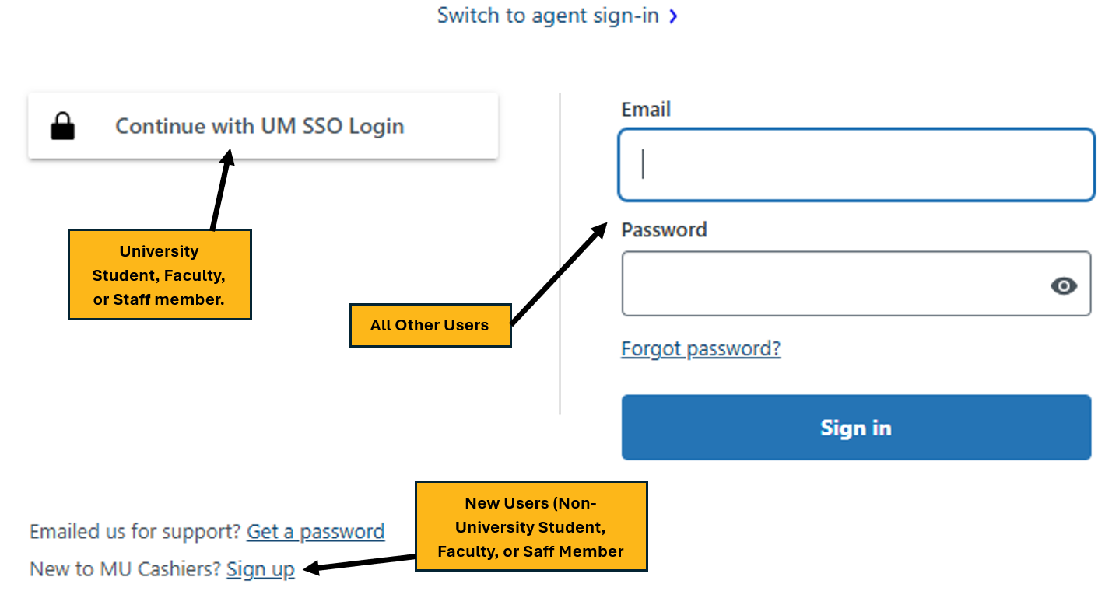
    - Signing in and setting up an account allows you to closely follow your request, as well as view any previous requests you have submitted. (See step 8 of these instructions for information on the “My Requests” screen)
- Step 3: Once you are signed in, click "Submit a request" at the top right-hand side of the screen.
- Step 4: Next, follow the prompts to submit a request.
  - You will be required to add a subject, description, and topic. (Attachments are allowed but not required)
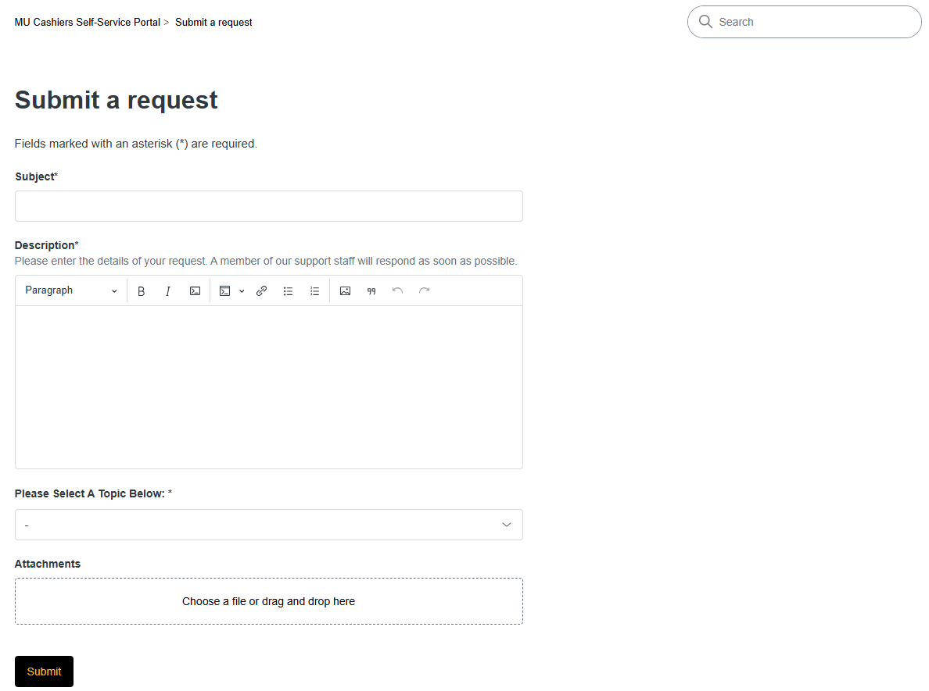
- Step 5: Once you have filled out all the required information, click "Submit" at the bottom.
- Step 6: After submitting your request, you will receive an email confirmation.
  - If you have not received this confirmation email, your request has NOT been submitted.
- Step 7: We will respond to your request via email as soon as possible.
- Step 8: You can also follow the status of your request, and respond to it, through the help center portal on your "My requests" screen. You can navigate there by clicking your name on the top right-hand corner of the screen and then selecting "Requests."
